Exp-1 AIM
To install VirtualBox / VMware Workstation on Windows 8 or above and to install different flavours of Linux or Windows operating systems as virtual machines.
REQUIREMENTS
- Windows 8 / 10 / 11 Operating System
- VirtualBox / VMware Workstation software
- ISO file of Ubuntu / Windows OS
- Minimum 4 GB RAM
- Virtualization enabled in BIOS

THEORY (BASIC EXPLANATION)
Virtualization is a technology that allows multiple operating systems to run on a single computer.
VirtualBox / VMware creates a virtual machine, which behaves like a real computer.
The existing OS is called the Host OS, and the OS installed inside the virtual machine is called the Guest OS.

PROCEDURE:
Step 1: Run the VirtualBox setups and click the “Next” option
Step 2: Repeat Click on “Next” option and Finally Click the option “Install”
Step 3: To Install “Ubuntu” as virtual machine in “Oracle VM VirtualBox”, Open the Oracle VM VirtualBox Manager
Step 4: Create new virtual machine
Step 5: Select the memory size
Step 6: Create a virtual hard drive
Step 7: Select the type of hardware file
Step 8: Select the type of storage on physical hard drive
Step 9: Select the size of virtual hard drive
Step 10: Select the new virtual OS created and click on “Settings”

Step 11: Select “Storage” from the left panel of the window
Step 12: Click on the first icon “Add CD/DVD device” in Controller:IDE
Step 13: Select “Choose Disk” and choose the virtual machine to be used and click “Open”
Step 14: Click “OK” and select “Start” to run the virtual machine
Step 15: To install ubuntu, Click 'Install Ubuntu' button
Step 16: Select 'Erase disk and install Ubuntu' option is selected and click 'Install Now' button
Step 17: Click 'Continue' button for upcoming dialogue box
Step 18: Enter the name, username and password. Click 'Continue' button
Step 19: After completion of installation process, click on 'Restart Now' button.
Step 20: The same way, we can install windows OS
OUTPUT:
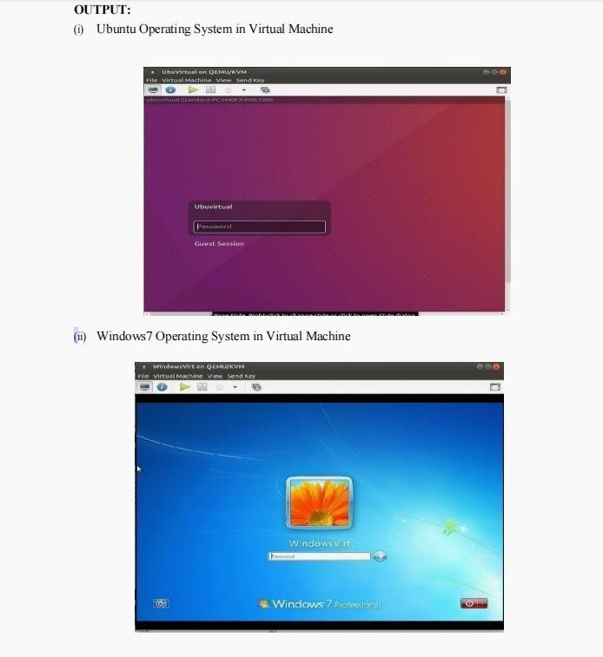

Exp-2
To design, develop, and test a simple RESTful Web Service using Python Flask, and test it using a browser and Postman.
AIM
To design, develop, and test a simple RESTful Web Service using Python Flask and verify the API using a web browser and Postman.

PROCEDURE (STEP-WISE)

STEP 1 — Create Project Folder
C:\RESTDemo Open CMD:
cd C:\RESTDemo

STEP 2 — Install Flask
pip install flask (If pip error)
python -m pip install flask

STEP 3 — Create app.py
from flask import Flask, request, jsonify app = Flask( name )
@app.route('/greet', methods=['GET']) def greet():
name = request.args.get('name', 'Student')
return jsonify({"message": f"Hello {name}, welcome to REST API!"}) if name == ' main ':
app.run(debug=True) STEP 4 — Run the API python app.py
Expected CMD Output:

Running on http://127.0.0.1:5000/ STEP 5 — Test in Browser Open:
http://localhost:5000/greet?name=Hema Expected JSON:
{
"message": "Hello Hema, welcome to REST API!"
}

STEP 6 — Test in Postman
- Open Postman
- Choose GET
- Enter URL:
http://localhost:5000/greet?name= Hema
- Click Send
Expected Response:
{
"message": "Hello Hema, welcome to REST API!"
}

OUTPUT (Expected)
- CMD running Flask server
- Browser displaying JSON message
- Postman showing GET request and JSON response

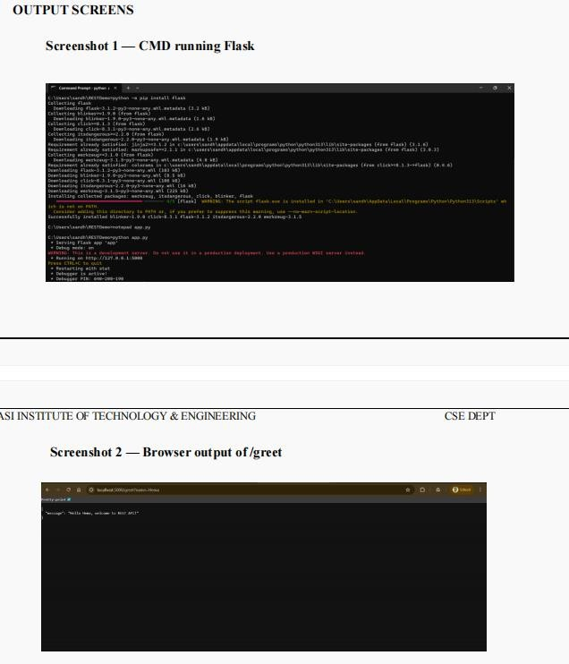

Exp-3
Install Google App Engine. Create a hello world app and other simple web applications using python/java.
AIM
To install Google App Engine (GAE) and develop a Hello World application and simple web applications using Python and Java.
REQUIREMENTS
  - Google account
  - Internet connection
  - Python 3.x
  - Java JDK 8 or later
  - Google Cloud SDK
  - Web browser THEORY
Google App Engine is a Platform as a Service (PaaS) provided by Google Cloud that allows developers to build and deploy web applications without managing servers.
It supports multiple programming languages such as Python and Java and automatically handles scaling, load balancing, and application updates.

PROCEDURE

Step 1: Install Google Cloud SDK
- Download Google Cloud SDK from: https://cloud.google.com/sdk
- Install the SDK and open the terminal (Command Prompt).
- Initialize the SDK: gcloud init
- Verify Google Cloud SDK Installation: gcloud --version
- Login using your Google account.
- Create or select a Google Cloud project: gcloud config set project even-hull-450506-t2
- Verify: gcloud config list
- Create App Engine Application: gcloud app create
- When prompted for region, Choose: asia-south1

PART A: HELLO WORLD APP USING PYTHON

Step 2: Create Project Directory
mkdir hello-python cd hello-python

Step 3: Create main.py (Python Hello World Application)
from flask import Flask app = Flask( name ) @app.route('/')
def hello():
return 'Hello World from Google App Engine (Python)!' if name == ' main ':
app.run()

Step 4: Execution of Python Application (Local).
The Python application was executed locally using the command: python main.py The output was viewed in the web browser using:
Open Chrome / Edge / any browser and type: http://localhost:8080

Step 5: Stop the server (after screenshot)
In Command Prompt, press: CTRL + C

Step 6: Creation of Simple Python Web Application
The Hello World program was modified to display the current date and time. from flask import Flask
from datetime import datetime app = Flask( name )
@app.route('/') def time():
return "Current Date and Time: " + str(datetime.now()) if name == ' main ':
app.run(port=8080)

Step 6: Creation of Java Hello World Application
A simple Java servlet program was created to display a Hello World message.
File: HelloServlet.java import java.io.IOException; import javax.servlet.http.*;
public class HelloServlet extends HttpServlet {
public void doGet(HttpServletRequest req, HttpServletResponse resp) throws IOException {
resp.setContentType("text/plain");
resp.getWriter().println("Hello World from Google App Engine (Java - Local)");
}
}
Step 7: Execution of Java Application (Local Environment)
The Java servlet program was compiled and executed using the local App Engine development setup for testing purposes.
Compile: javac HelloServlet.java

OUTPUT
- Python Hello World message displayed successfully in the browser
- Python web application displaying current date and time
- Java Hello World servlet program executed successfully

Exp-4

Create an Amazon EC2 instance and set up a web-server on the instance and associate an IP address with the instance. In the process, create a security group allowing access to port80 on the instance (OR) Do the same with
OpenStack
AIM
To create an Amazon EC2 instance, set up a web server on it, allow access on port 80, and access the website using an IP address.
What is EC2? (Very Basic)
Amazon Web Services EC2 (Elastic Compute Cloud) is a service that lets you rent a computer (called an instance) on the internet.
This computer:
- Runs 24/7
- Has an operating system (Linux / Windows)
- Can host websites What is a Web Server?
A web server is software that shows a web page when someone types an IP address in a browser.
We will use:
- Apache Web Server (httpd) Requirements
- AWS account
- Internet
- Laptop / PC
IMPORTANT POINTS
- Amazon Web Services (AWS) is a cloud computing platform that provides on-demand computing resources over the internet.
- EC2 (Elastic Compute Cloud) is an AWS service that provides virtual servers called instances to run applications and websites.

- An EC2 instance is a virtual computer that runs in the AWS cloud with a selected operating system such as Linux or Windows.
- A web server is software that delivers web pages to users when they access a website through
a browser.
- Apache HTTP Server (httpd) is a commonly used open-source web server for hosting websites on Linux systems.
- A security group acts as a virtual firewall that controls incoming and outgoing network traffic
for an EC2 instance.
- Inbound rules in a security group define which traffic is allowed to enter the instance.
- Port 80 is the default port used for HTTP communication and must be enabled to access web
pages.
- SSH (port 22) is used to securely connect to the EC2 instance for configuration and management.
- A public IP address allows the EC2 instance to be accessed from the internet.
- An Elastic IP address is a static public IP provided by AWS that remains unchanged even after restarting the instance.
- Key pairs are used for secure authentication while connecting to an EC2 instance.
- The AWS Management Console is a web-based interface used to manage AWS services.
- Cloud computing enables scalability, flexibility, and cost-effective resource usage.

PROCEDURE
Step 1: Open AWS Console
- Open browser
- Go to https://aws.amazon.com
- Click Sign In → Console Home
- Login using your email & password
Step 2: Open EC2 Service
- In the search bar, type EC2

- Click EC2
- You are now in the EC2 dashboard
Step 3: Launch a Virtual Machine (Instance)
- Click Launch Instance
- Enter Name: parthimitit
Step 4: Choose Operating System
- Select Amazon Linux 2
o This is a free Linux OS provided by AWS
Step 5: Choose Instance Type
- Select t2.micro
o Free Tier
- Click Next
Step 6: Create a Key Pair (Login Password)
- Click Create new key pair
- Name: mykey
- Type: RSA
- Download .pem file
o Do not delete this file
Step 7: Create Security Group (Firewall)
A Security Group controls which traffic is allowed.
- Select Create new security group
- Add rules:
Purpose Port Source SSH (Login) 22 My IP
HTTP (Website) 80 Anywhere This allows:
  - You to login (SSH)
  - Everyone to see the website
Step 8: Launch the Instance

- Click Launch Instance
- Wait until status shows Running
Step 9: Get Public IP Address
- Click your instance
- Copy Public IPv4 address
This IP is used to access your website.
Step 10: Connect to the Instance
- Click Connect
- Choose EC2 Instance Connect
- Click Connect
Now you are inside the cloud computer
Step 11: Install Web Server
Type these commands one by one: sudo yum update -y
sudo yum install httpd -y sudo systemctl start httpd sudo systemctl enable httpd
- This installs Apache web server
- Starts it
- Enables it permanently
Step 12: Create a Website cd /var/www/html
sudo nano index.html Type:
<h1>Hello World from EC2</h1> Save and exit.
Step 13: Open Website
- Open browser
- Enter:

http://<Public-IP>
You will see your webpage
How to Stop an EC2 Instance Safely
- Go to EC2 → Instances
- Select the instance (tick the checkbox)
- Click Instance state (top right)
- Click Stop instance
- Click Stop to confirm
Wait until Instance state = Stopped

Exp-5
To develop, publish, and test a simple SOAP Web Service using Java JAX-WS (stand-alone method) and test it using SoapUI.
AIM
To develop, publish, and test a simple SOAP Web Service using Java JAX-WS and test it using SoapUI, without using any external server or IDE.

PROCEDURE (STEP-WISE)

STEP 1 — Create Project Folder
C:\SOAPDemo Open CMD:
cd C:\SOAPDemo

STEP 2 — Create Java Files
- HelloService.java
import javax.jws.WebService; @WebService(
targetNamespace = "http://service.hello/"
)
public class HelloService { public String sayHello() {
return "Hello Hema, welcome to SOAP Web Service!";
}
}
- HelloPublisher.java
import javax.xml.ws.Endpoint; public class HelloPublisher {
public static void main(String[] args) {
String url = "http://localhost:9090/hello"; Endpoint.publish(url, new HelloService());
System.out.println("SOAP Service running at: " + url + "?wsdl");

}
}

STEP 3 — Compile Java Files
javac *.java

STEP 4 — Run the Web Service
java HelloPublisher Expected CMD Output:
SOAP Service running at: http://localhost:9090/hello?wsdl

STEP 5 — Test WSDL in Browser
Open:
http://localhost:9090/hello?wsdl

STEP 6 — Test SOAP Request in SoapUI
- Open SoapUI
- File → New SOAP Project
- Enter WSDL:
http://localhost:9090/hello?wsdl
- Open Request1
- Replace body with:
<soapenv:Envelope
xmlns:soapenv="http://schemas.xmlsoap.org/soap/envelope/" xmlns:ser="http://soapdemo/">
<soapenv:Header/>
<soapenv:Body>
<ser:sayHello>
<name> Hema </name>
</ser:sayHello>
</soapenv:Body>
</soapenv:Envelope>
- Click Run

Expected Response:
<return>Hello Hema, welcome to SOAP Web Service!</return>

OUTPUT (Expected)
- CMD showing:
- SOAP Service running at: http://localhost:9090/hello?wsdl
- Browser displaying WSDL XML structure
- SoapUI showing request and response message
